Pranav Rajan

January 25, 2019

Professor Varun Shankar

Polynomial Interpolation Analysis

Synopsis

The purpose of this assignment was to learn about polynomial interpolation and how we can use interpolation to recover functions to learn more about the data sets that we are given that contain only a few discrete sampled points. The function that was analyzed in the following is Runge’s Phenomenon defined as f(x) = 1/(1 + 25 x2) , x [-1,1]. Runge’s Phenomenon shows that when we attempt to interpolate this function at equidistant points the polynomial oscillates at the very ends of the bounds of -1 and 1 (Professor Shankar Notes). As the degree of the polynomial increases and the number of points increases the error increases. When graphing Runge’s Phenomenon with polynomial interpolation and equispaced points, the interpolation diverges and we get a lot of noise. With interpolation we are attempting to figure what is the best way to approximate and model a function as mentioned above. So how do we do that while trying to obtain a high degree of precision? There are many different kinds of interpolation that provide more accurate approximations depending on the scenario and there are certain things we can apply to polynomial interpolation to get more accurate results and reduce error such as using Chebyshev Extrema with Barycentric Lagrange Interpolation instead of equispaced points and vandermode matrices. The following explanations are based on coding Runge’s Phenomenon and applying polynomial interpolation with different methods such as MATLAB’s polyfit/polyval function, Chebyshev Extrema, equispaced points, Barycentric Lagrange Interpolation, and the Vandermode Matrix.

1. For part a, the vandermode matrix was built on Chebyshev Extrema. 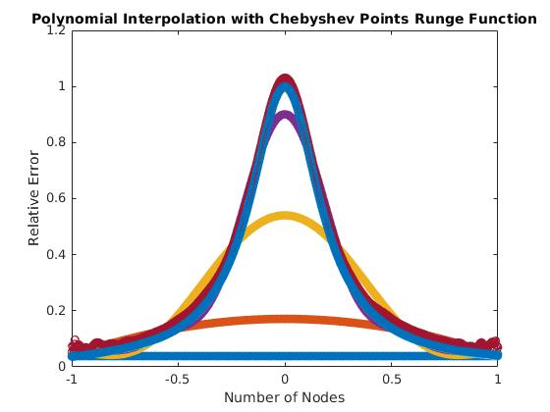

As we can from the above graph diagram, we get a much more accurate approximation of Runge’s phenomenon by using Chebyshev Extrema which attempt to cluster data points toward the ends of the above interval from -1 to 1. What makes Chebyshev Extrema useful is that they minimize the product from the polynomial error estimate. Using the equation for error,

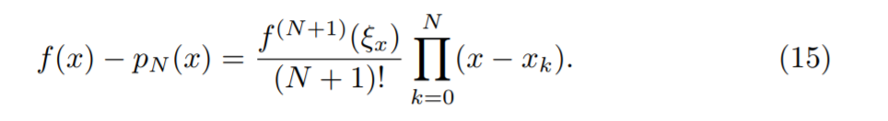

we can see that N (the number of points) increases, the error decreases geometrically if the derivative stays bounded (Professor Shankar Notes). By using Chebyshev spaced points according to the following equation 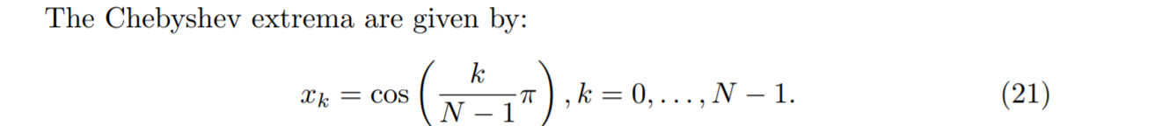

we can reduce the product term of the polynomial error equation. Since cosine oscillates between the values of -1 to 1, the product will be small for n number of nodes. Thus we have somewhat accurate approximation of Runge’s Phenomenon compared to approximations that have significant noise as the degree increases with equispaced points.

1. For part b, the following graphs display the condition number of the Vandermonde matrix vs the number of points that are both equispaced and spaced using Chebyshev Extrema.

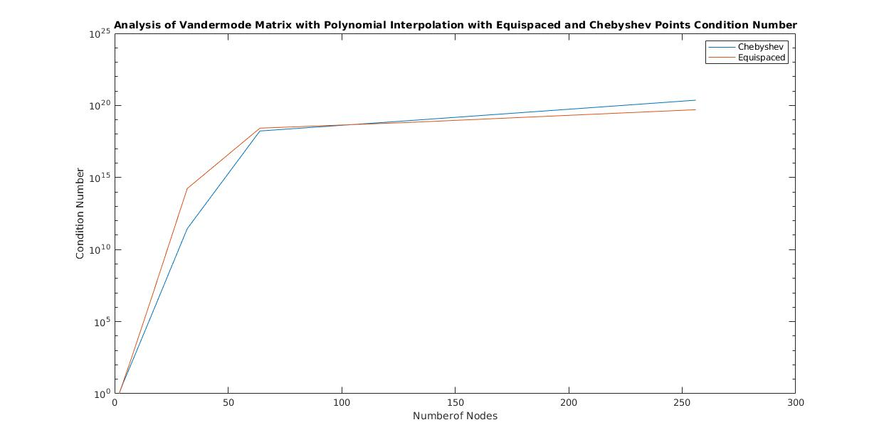

As defined in the notes of Professor Shankar, when using Vandermonde matrices for polynomial interpolation we have to worry about the matrix being singular which means the determinant does not exist and there is no inverse for that specific matrix. Since there is a difference between how zero is defined for computers (10-16) and 0 in mathematics, we have to worry about how close to zero we are for precision when solving a vandermonde matrix using gaussian elimination. As the Vandermonde matrices are ill conditioned and from the above plots we can see that both Chebyshev and equispaced points are very close to 10^20 as the number of points increases. This is a big problem since computers store 16 digit precision when using double precision which means using polynomial interpolation and vandermode matrices will also be innaccurate for single precision arithmetic. Thus to increase the precision we have to find other solutions for interpolation that do not use the vandermonde matrix such as barycentric lagrange.

1. For part c, the following graphs were constructed by reducing the number of nodes to 9 and 50. The first two graphs use linear spaced points

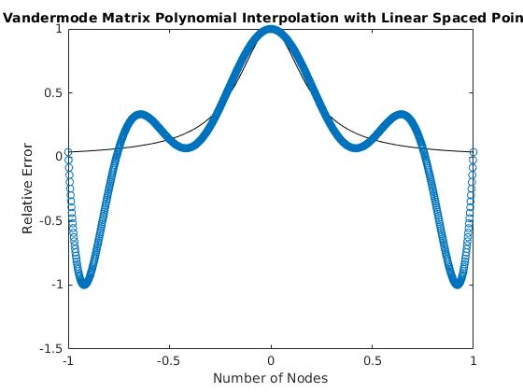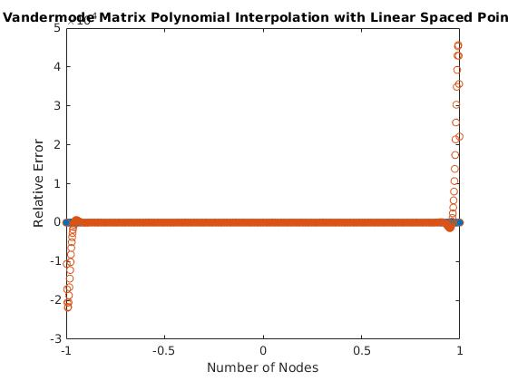

As we increase the number of points we can see that there is a lot noise even when the number of nodes are 9 and 50. Compare this to the next two graphs which use Chebyshev spacing

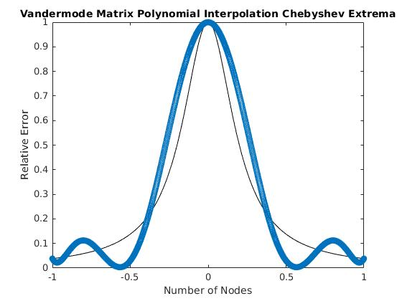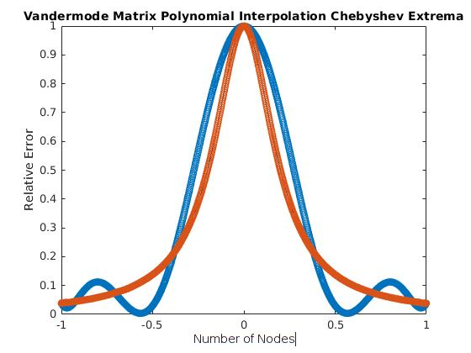

These two graphs have less noise than the first two graphs above but as we increase the number of points we get a much tighter approximation of the Runge Phenomenon. However, this entire time we have not discussed the computational cost that goes into computing the polynomial approximation that goes into computing accurate approximations. As engineers we have to worry about the cost since we want to produce accurate results with constraints such as precision, money, time etc. The Vandermonde matrix interpolation approach is very costly with a cost of Big O(N3) which is due to going through all the rows and columns of the matrix to perform gaussian elimination. In the last three examples, we will look different interpolation method, their accuracy and their cost.

1. The following example is a plot of the time of a polynomial interpolant using Chebyshev extrema and the vandermonde approach.

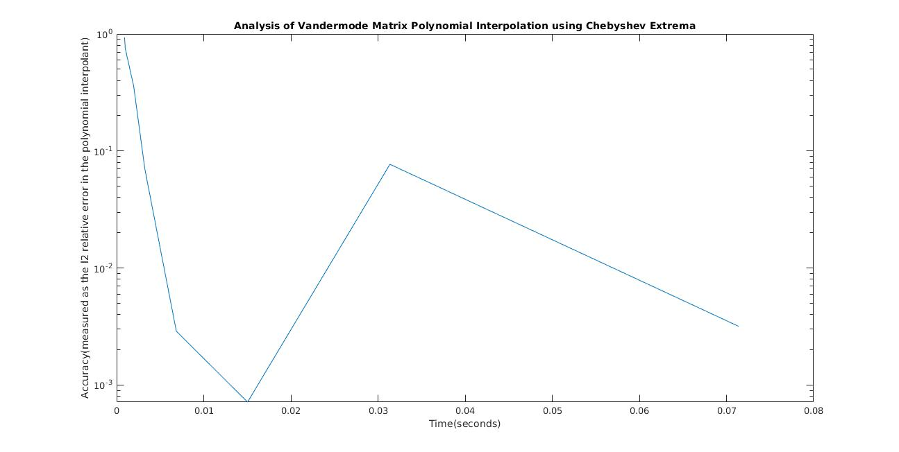

Looking at the data given above we can see that the accuracy decreases for this approach sharply before increasing as the time increases. As mentioned above the Big O for the Vandermonde approach is Big O (N3) where N represents the number of data points. Thus looking at this graph, we can see that as the time increases the accuracy will decrease.

1. The following example uses barycentric lagrange interpolation with Chebyshev extrema spaced points.

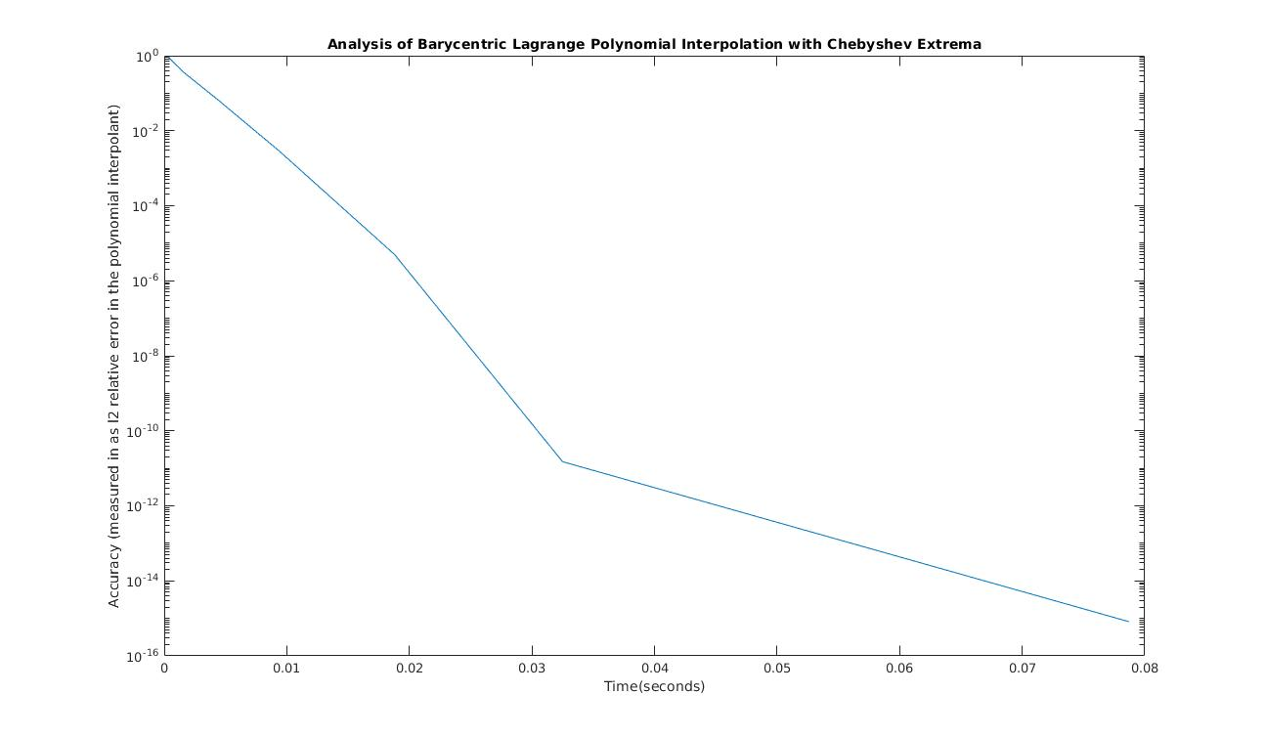

The graph above show the barycentric lagrange polynomial interpolation. This method attempts to avoid the costs of things such as Gaussian Elimination which as we have shown above in the previous part is very costly in terms of time complexity and accuracy. As time increases for this graph, the accuracy gets better with time and can approximate a function with a high degree of precision. As mentioned in Professor Shankar’s notes the time cost is less costly than vandermonde with a complexity of O(N) for each new node.

1. The following example uses the matlab function polyfit and polyval using Chebyshev extrema spaced points.

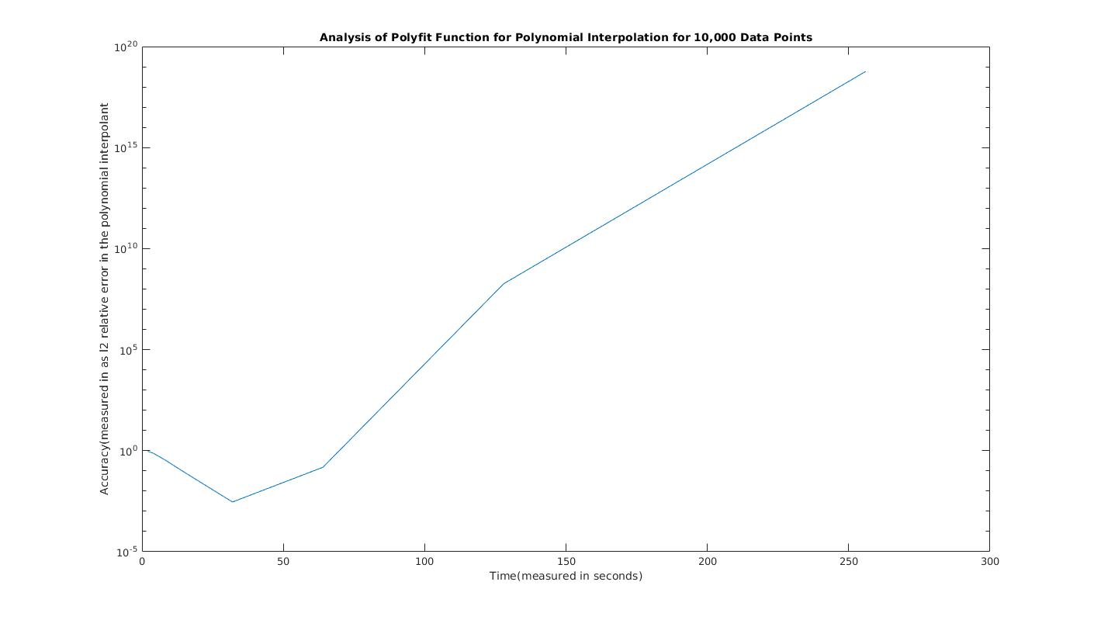

This graph was very similar to the vandermonde approach so I looked the matlab documentation and saw that MATLAB implements the polyfit approximation using a vandermonde approximation and a type of factorization called QR factorization. In terms of accuracy and cost when compared to the barycentric form, the polyfit is very costly and not as accurate since the accuracy decreases as the time increases. In comparison to the vandermonde approach, the graph is very similar. We can see that for both the polyfit and vandermonde as time increases, the accuracy decreases. Thus we now know that using MATLAB’s interpolation tool is very costly and that we should be using better interpolation techniques that can be coded.